Assignment -2:

Name: Mylarapu Ravi

Ph no: 6302540471

Mail-id: ravimylarapu39@gmail.com

Batch: 119

Date: 23-02-2024

TRANSIT GATEWAY MULTIBLE REGION ASSIGNMENT

1.First create a VPC

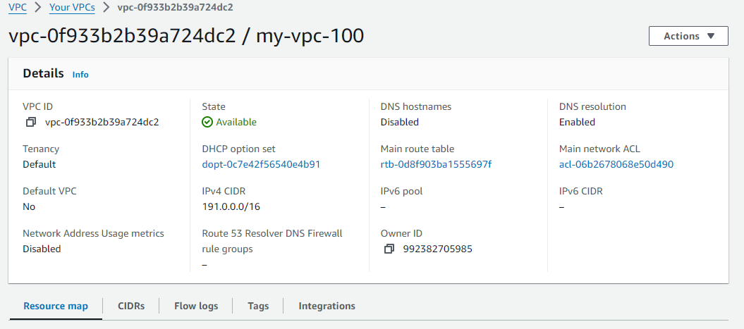

2.Next create a subnet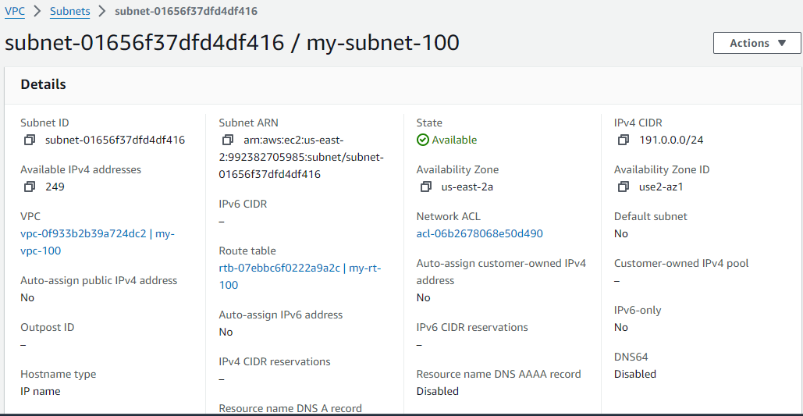

3.Next create internet gateway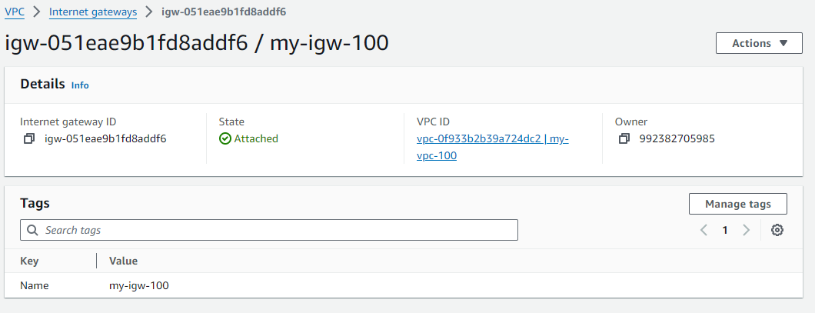

4.Next create route table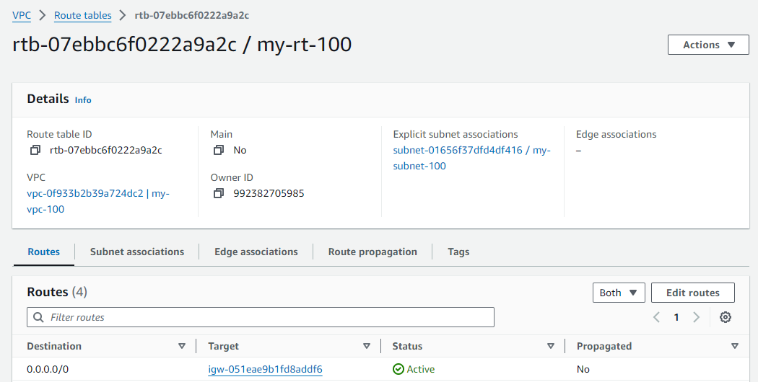

5.Next create transit gateway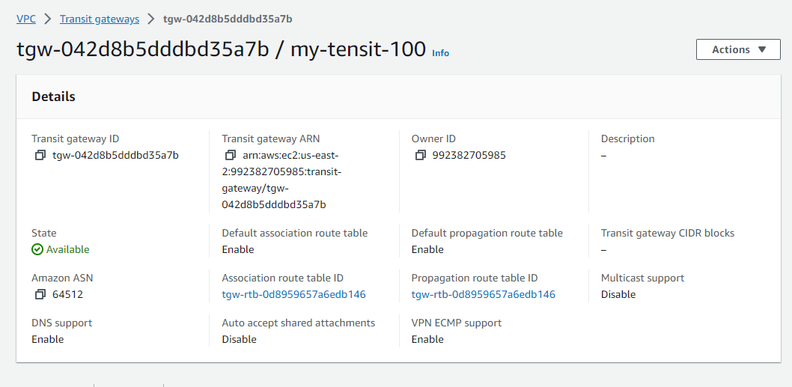

6.Next create ec2 instance and go so the security and change the inbound rules and connect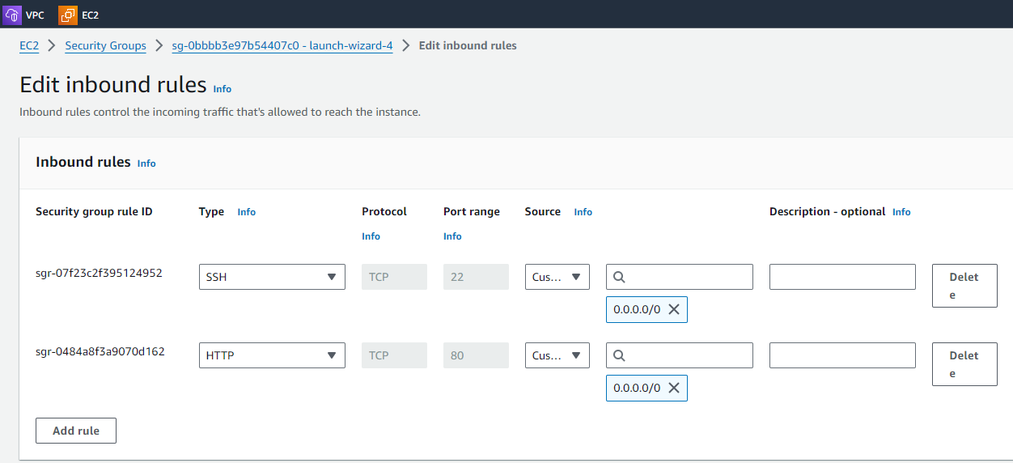

7.Next install nginx

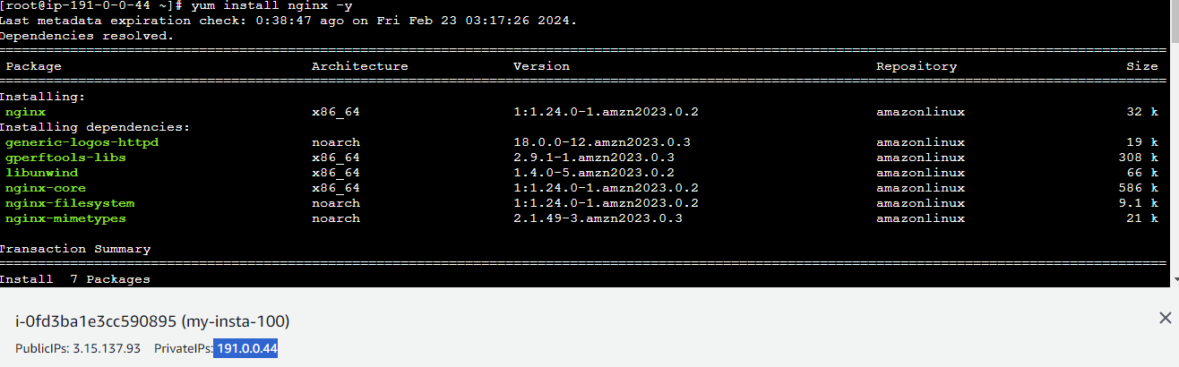

8.Next use vi command and insert the data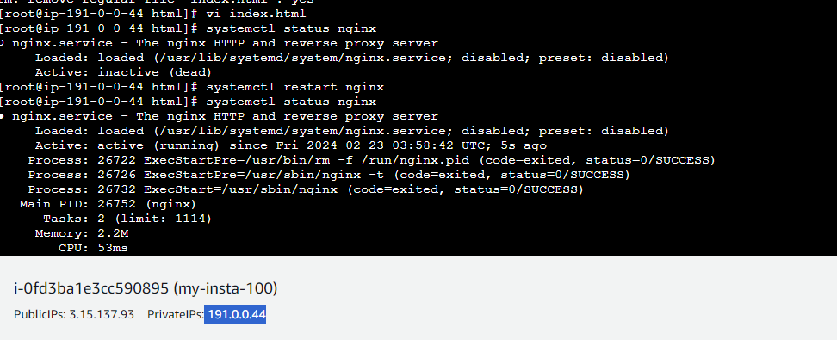

9.Next copy the public ip address and paste the ip in web adding port range :80 to check the connection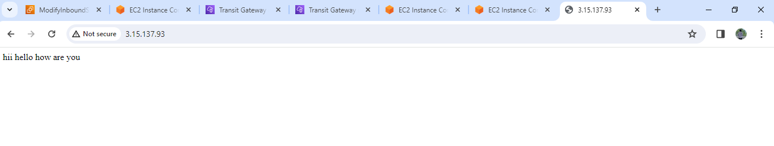

10.repeat the process in another vpc creating like (vpc, subnets, internet gateway, route table, instance, internet gateway Connections established vpc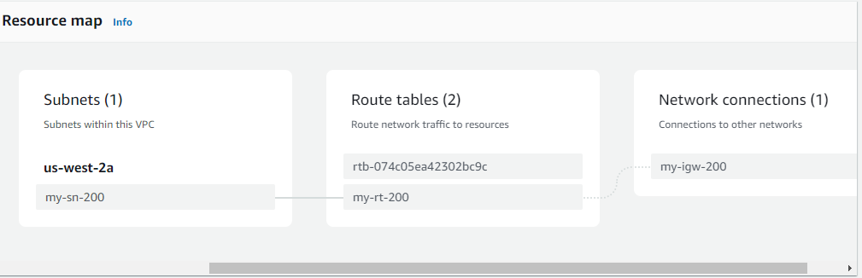

11.next go route table and edit routes attach internet gateway and inter change ip addresses 1st to 2nd 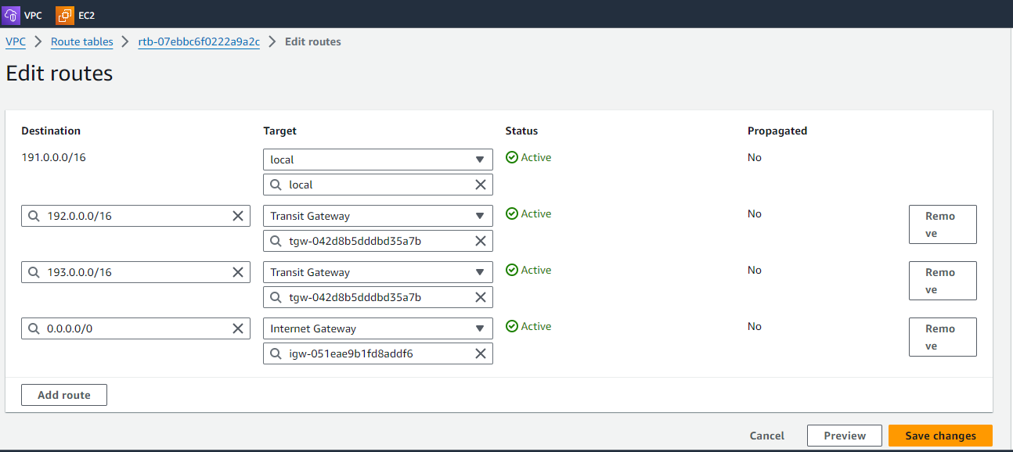

12.next create transit gateway in both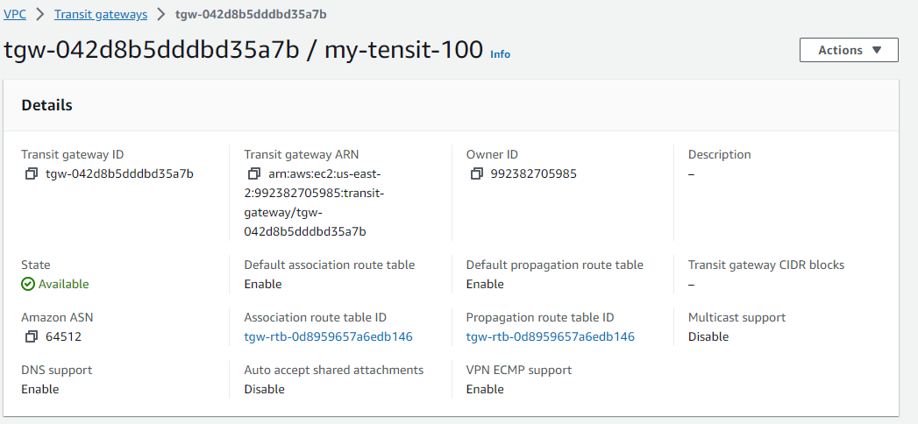

13.next go to transit gateway attachments and interchange ip addresses and select the peering connection option in both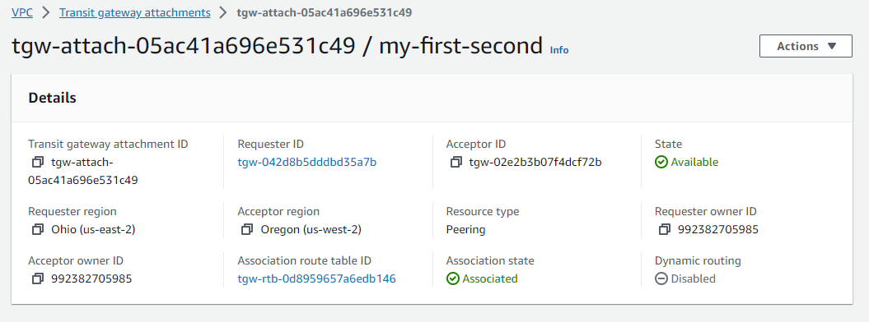

14.next go to another region vpc transit gateway attachment and accept the attachment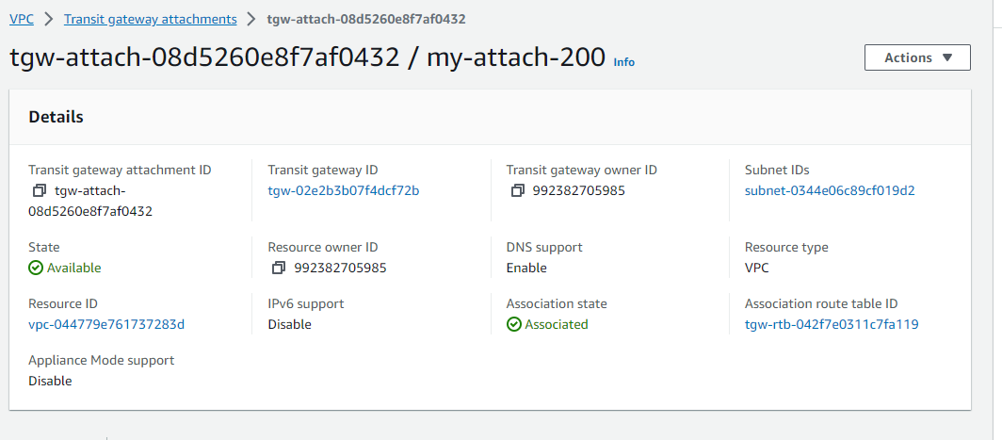

15.next go to the transit gateway route table and go to route and create static route and inter change ip addresses in both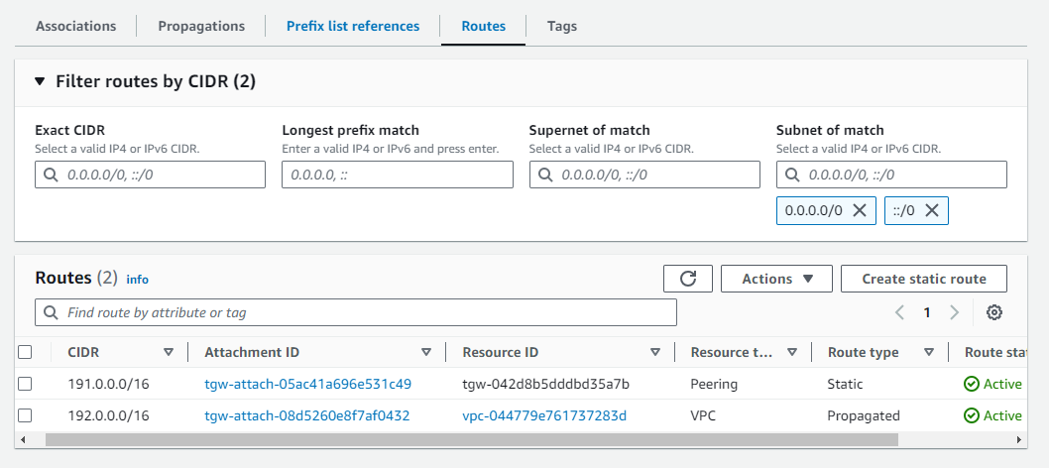

16.let’s move on to the another region go to instance and connect use curl command and copy the private addess :80 see the first region inserting data. 